Lesson 13: Amplitude and Midline

Cool Down: Transforming a Sine Graph
- Sketch a graph of the function $f$ given by $f\left(θ\right)=2sin\left(θ\right)$.
- 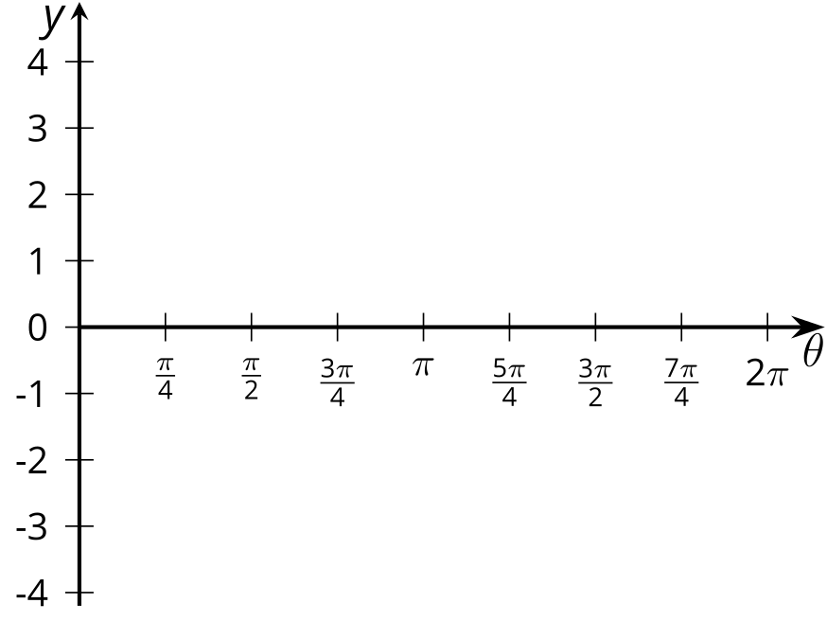
- Sketch a graph of $g$ given by $g\left(θ\right)=sin\left(θ\right)+3$.
- 

